**Machine Learning to Understand & Predict MLB Teams Success**

**Introduction: -**

In the competitive realm of Major League Baseball (MLB), predicting team performance is vital for strategic decision-making and resource allocation. Accurate forecasts of team success can guide managers in player acquisitions, game strategies, and financial investments. This project aims to develop a robust machine learning model that forecasts the number of wins for MLB teams in the 2015 season based on performance indicators from the 2014 season. By comprehending the key metrics driving team success, we can offer invaluable insights to team managers and analysts, helping them make data-driven decisions.

Baseball is a sport rich in statistics, with a long history of data collection and analysis. The advent of advanced analytics, often referred to as sabermetrics, has transformed how teams evaluate players and strategies. Traditional statistics like batting averages and earned run averages are now complemented by sophisticated metrics such as Wins Above Replacement (WAR) and Fielding Independent Pitching (FIP). Our project leverages this wealth of data to build predictive models, harnessing both classical and modern statistical techniques.

Machine learning, a subset of artificial intelligence, offers powerful tools for pattern recognition and predictive modelling. By training algorithms on historical data, we can uncover hidden relationships between various performance metrics and future outcomes. Our goal is to apply these techniques to predict the number of wins for MLB teams, providing a quantitative basis for evaluating team strengths and weaknesses.

In this study, we utilize a dataset comprising 16 features that capture diverse aspects of a team's performance in the 2014 season. These features include traditional statistics such as runs scored and home runs, as well as defensive metrics like errors and earned run average. By analysing these features, we aim to identify the key drivers of team success and construct a model that accurately predicts future performance.

In summary, our project not only seeks to predict the number of wins for MLB teams but also aims to enhance the understanding of the factors that contribute to winning games. This endeavour bridges the gap between historical performance data and future success, offering practical insights for teams, analysts, and fans alike.

**Dataset Overview: -**

We utilized the 2014 Major League Baseball dataset, The dataset provides a comprehensive view of both offensive and defensive metrics, which are essential for building a predictive model.

The dataset used in this study includes 30 teams, with each row representing a team and 16 features describing various aspects of the team's performance. These features include traditional statistics like runs scored, home runs, and earned run average, as well as defensive metrics like errors. By analysing these features, we aim to identify the key factors that contribute to a team's success and build a predictive model to estimate the number of wins.

Below is a detailed description of the dataset features:

|  |  |
| --- | --- |
| Feature | Description |
| W (Wins) | Number of wins credited to a pitcher. |
| R (Runs) | Total runs scored by a team. |
| AB (At Bat) | Plate appearances of a batter. |
| H (Hits) | Number of times a batter safely reaches or passes first base. |
| 2B (Doubles) | Hits where a batter safely reaches second base. |
| 3B (Triples) | Hits where a batter safely reaches third base. |
| HR (Home Runs) | Hits where a batter successfully circles the bases and reaches home plate. |
| BB (Base on Balls) | Occurs when a batter receives four pitches called balls and is awarded first base. |
| SO (Strikeouts) | Number of batters who accumulate three strikes during an at-bat. |
| SB (Stolen Bases) | Number of bases advanced by a runner while the ball is in possession of the defines. |
| RA (Run Average) | Measures the rate at which runs are allowed or scored. |
| ER (Earned Runs) | Runs that occur due to offensive production against competent defensive play. |
| ERA (Earned Run Average) | Average number of earned runs a pitcher allows per nine innings pitched. |
| SV (Saves) | Number of games a relief pitcher finishes for the winning team. |
| E (Errors) | Acts of fielder misplay allowing a batter or baserunner to advance. |

**Objective: -**

The objective of this project is to develop a machine learning model that predicts the number of wins for Major League Baseball teams in the 2015 season. By analysing historical data from the 2014 season, the model aims to understand the relationship between various performance metrics and the number of wins, aiding in strategic decision-making and performance evaluation.

**MLB Team Success & Performance Dataset: -**

In this case study we will use MLB Team Success database. Discover open data pertaining to Major League Baseball (MLB), collaboratively contributed by numerous users and organizations worldwide and available to download from GitHub and Kaggle. You can also download dataset from my [GitHub Profile](https://github.com/javedns07/Project-Evaluation/blob/main/1.Baseball%20Case%20Study.ipynb). This dataset consists of 30 rows, which includes 16 features that capture various aspects of a team's performance

We have two objectives here:

1. Identify Key Factors Influencing Team Success.
2. Build a Machine Learning Model to Predict Team Wins.

**Data Preparation: Load, Clean and Format**

Data preparation is a critical step in any machine learning project. We began by loading the dataset and performing initial data cleaning, which included handling missing values and duplicates. The following steps were taken to prepare the data for analysis:

1. **Handling Missing Values**: We checked for any missing values in the dataset and used appropriate imputation techniques to fill in the gaps.

2. **Removing Duplicates**: Duplicate records were identified and removed to ensure the integrity of the dataset.

3. **Initial Statistical Analysis**: Basic statistical analysis was performed to understand the distribution of each feature and identify any anomalies or outliers.

Let’s begin with importing libraries for EDA and dataset itself.

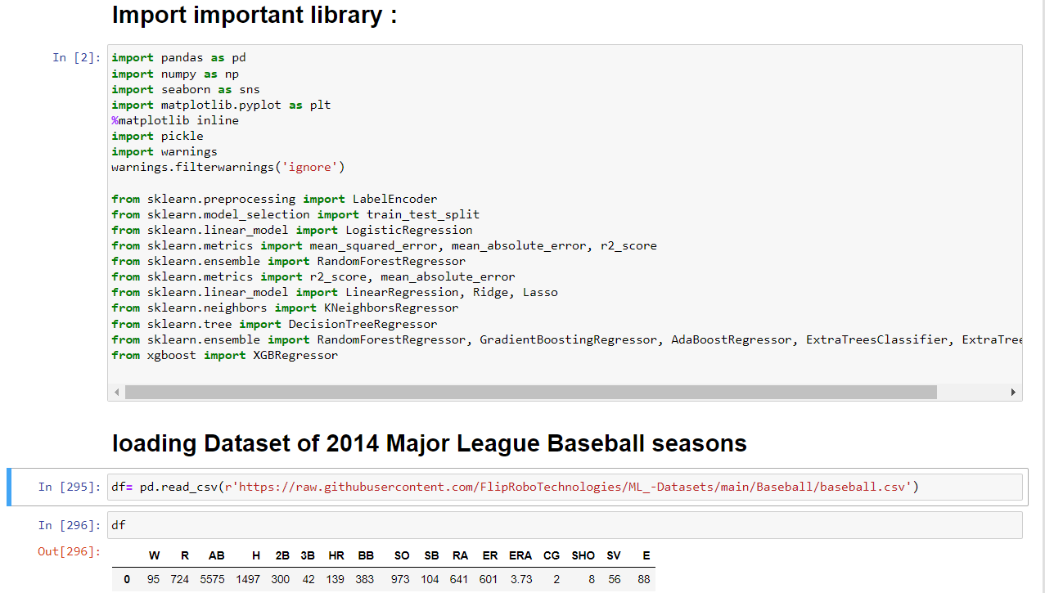

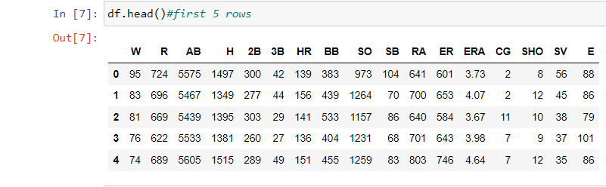

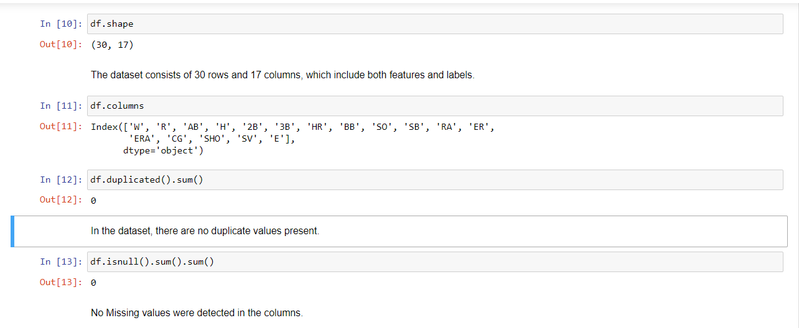

Checking different datatypes in dataset: -

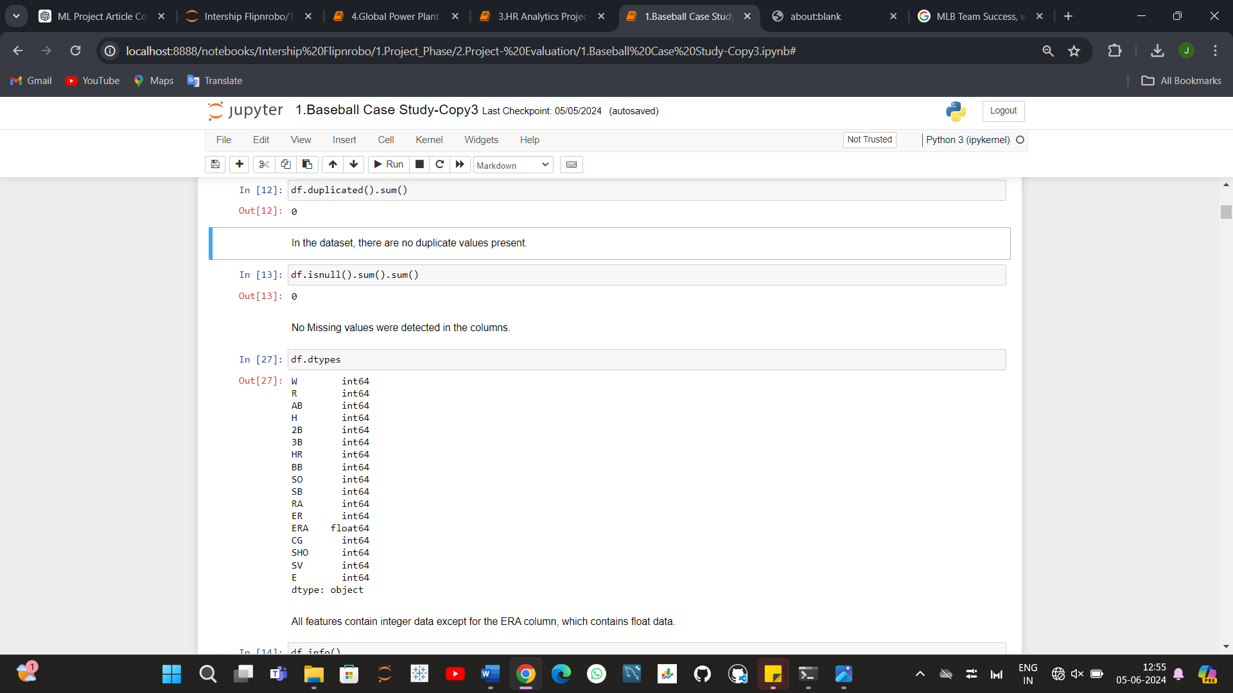

All features contain integer data except for the ERA column, which contains float data.

**Data Integrity Check:** Dataset can have missing values, duplicated entries and whitespaces. Now we will perform this integrity check of dataset.

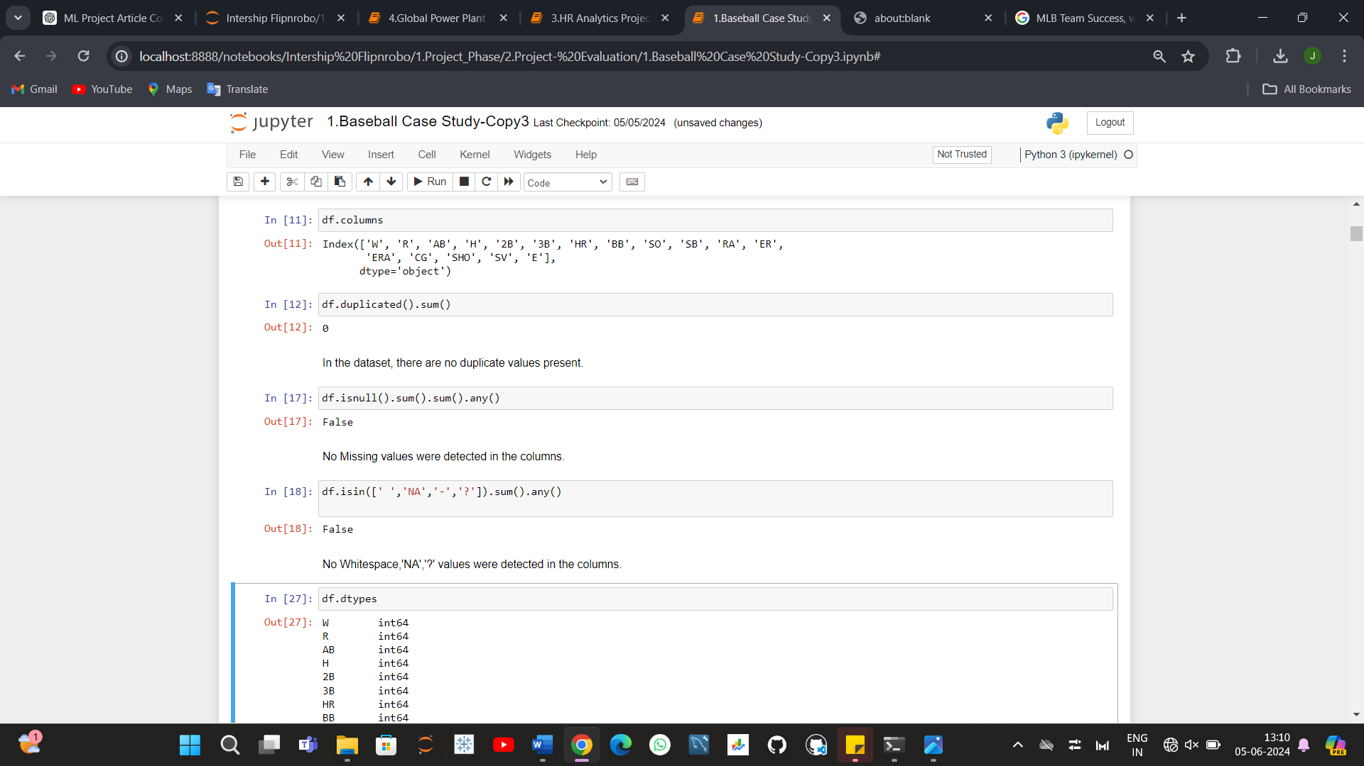

Luckily for us, there is no missing data! this will make it easier to work with the dataset.

Dataset doesn’t contain Any duplicate entry, whitespace, ‘NA’, or ‘-’.

**So, Yes Good to Go Further!!!**

Statistical parameters like mean, median, quantile can give important details about database. Now is time to look at statistical Matrix of Dataset.

*Few key observations from this statistical matrix are listed below: -*

* The dataset encompasses performance metrics for 30 baseball teams, showcasing balanced averages, such as around 81 wins.
* Variability among teams is notable, with win ranges spanning from 63 to 100 and runs scored ranging from 573 to 891.
* Median values highlight that half of the teams secure up to 81 wins and score approximately 689 runs, revealing significant discrepancies between the top and bottom quartiles in offensive metrics.
* Pitching and defensive statistics, such as ERA, hover around 3.96 on average, reflecting considerable diversity in team performance as evidenced by standard deviations and the spectrum of values across metrics like shutouts and errors.

**Exploratory data analysis**

**Exploratory Data Analysis refers to the critical process of performing initial investigations on data so as to discover PATTERNS, TO spot ANOMALIES, TO test hypothesis and to check assumptions with the help of summary statistics and graphical representations.**

# **Data Visualization: -**

# **1.Univariate Analysis-**

**1. Histplot.**

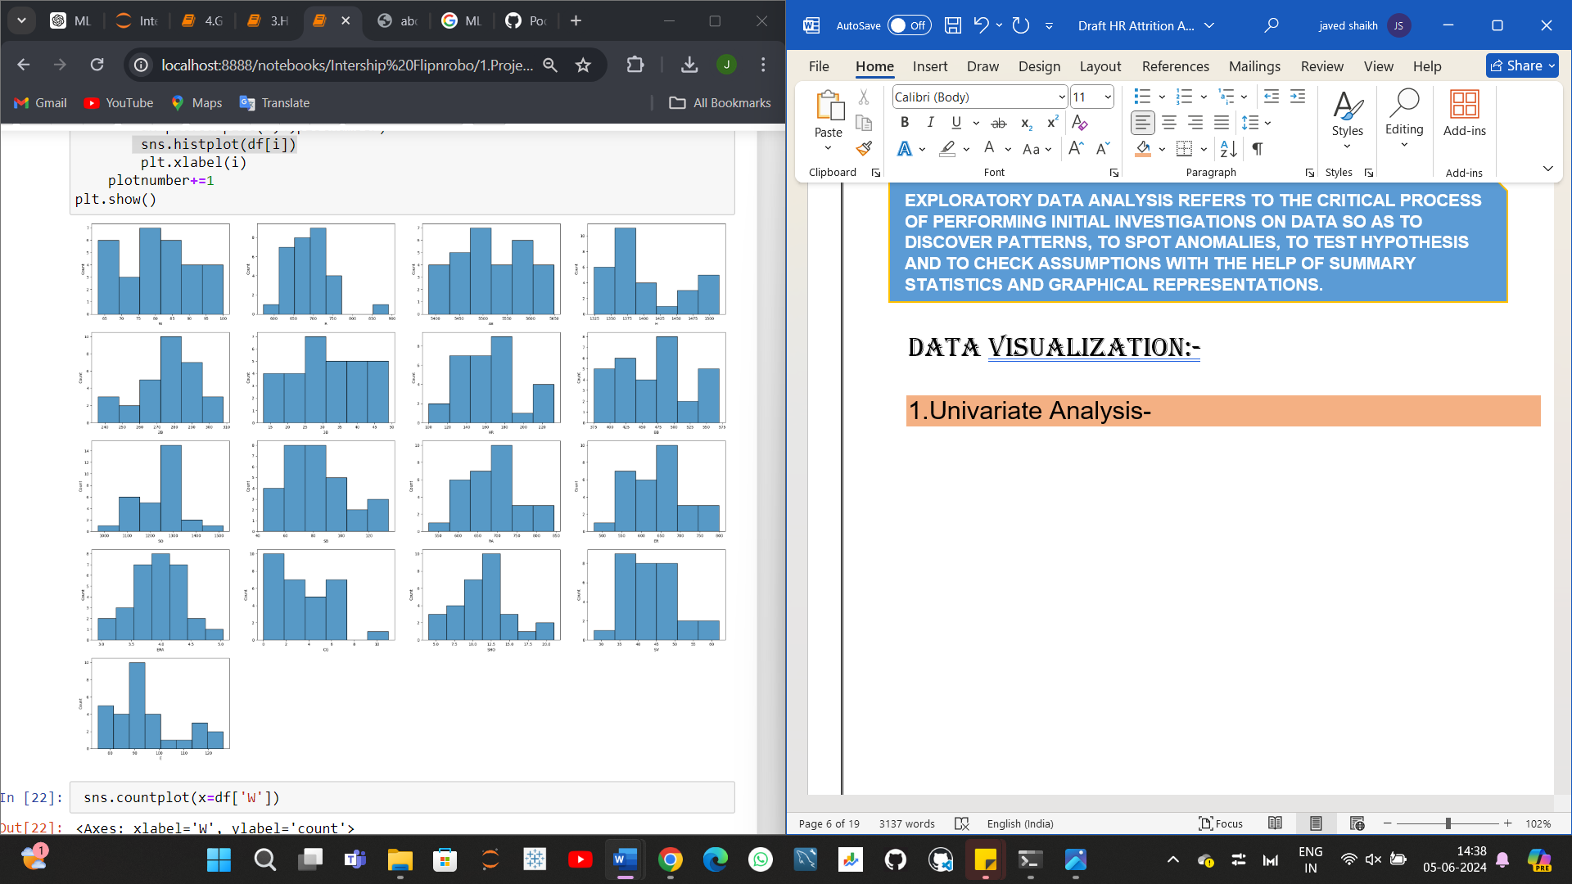

*Few key observations from this histogram*

* The distribution of each column data can be observed from the above histplot.
* The number of wins is distributed between 60 and 100.
* Runs scored are distributed within the range of 550 to 890.
* At-bats are distributed from 5400 to 5650.
* Hit column data is distributed between 1325 and 1500.
* Two-base hit column data falls within the range of 240 to 310.
* Triple column data is distributed from 15 to 50.
* Home runs column data ranges from 100 to 210.
* Base on ball column data is distributed between 375 and 575.
* Strikeout column data ranges from 1050 to 1500.
* Stolen base column data falls between 40 and 130.
* Run average data is distributed from 530 to 850.
* Earned run data falls within the range of 500 to 800.
* Earned run average data is distributed from 3.0 to 5.0.
* Complete game data ranges from 0 to 30.
* Shutout column data falls within the range of 5.0 to 20.0.
* Save column data is distributed between 30 and 60.
* Error column data ranges from 75 to 125.

# **2.Bivariate analysis-**

**2.Barplot.**

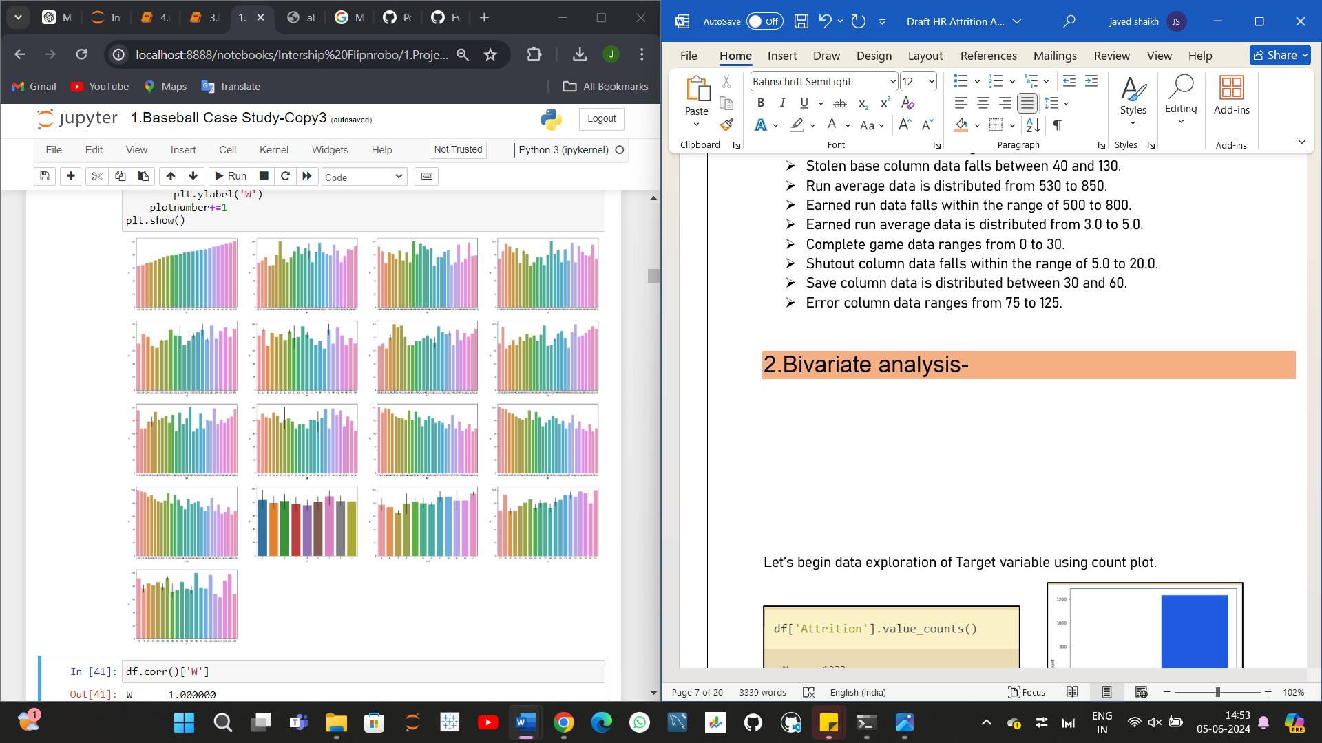

*Few key observations from this Barplot plotted between Features and target: -*

* it's evident that the number of wins is not evenly distributed with respect to R.
* it's apparent that the number of wins is not evenly distributed with respect to AB. No specific or consistent pattern between AB and W can be observed.
* It appears there's no discernible pattern between H and W in the barplot.
* Once more, there seems to be no clear pattern between 2B and W in the barplot.
* Uneven distribution can be observed in the 3B vs. W plots.
* No relational pattern can be observed between HR and W.
* An uneven distribution can be observed between BB and W.
* Uneven distribution can be observed between SO and W.
* Uneven distribution can be seen in bw SB & W.
* A decreasing pattern can be observed between RA and W, indicating a negative relationship between RA and W.
* A decreasing pattern can be observed between ER and W, as ER increases, the number of wins decreases.
* A decreasing pattern can be observed between ERA and W, as ERA increases, the number of wins decreases.
* No specific pattern can be observed between CG and W.
* An increasing pattern can be observed between SV and W, as SV increases, W also increases.
* An uneven distribution or pattern can be observed between SHO and W.
* An uneven distribution or pattern can be observed between E and W.

# **3.Multivariate analysis-**

**3.Lineplot.**

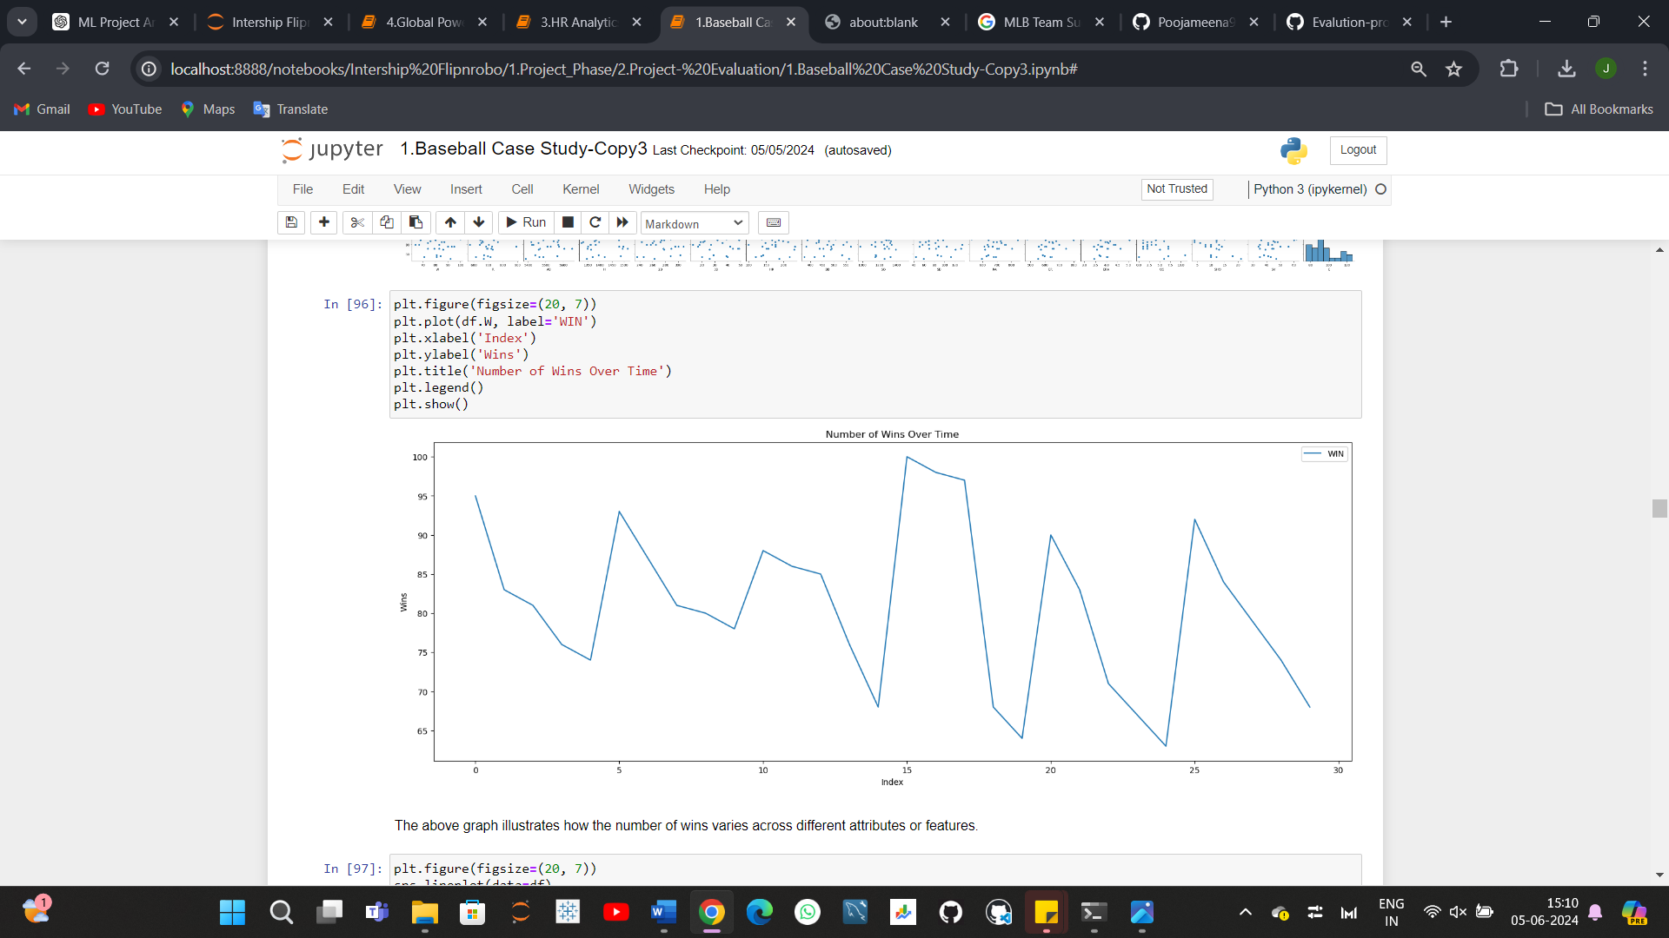

The above graph illustrates how the number of wins varies across different attributes or features.

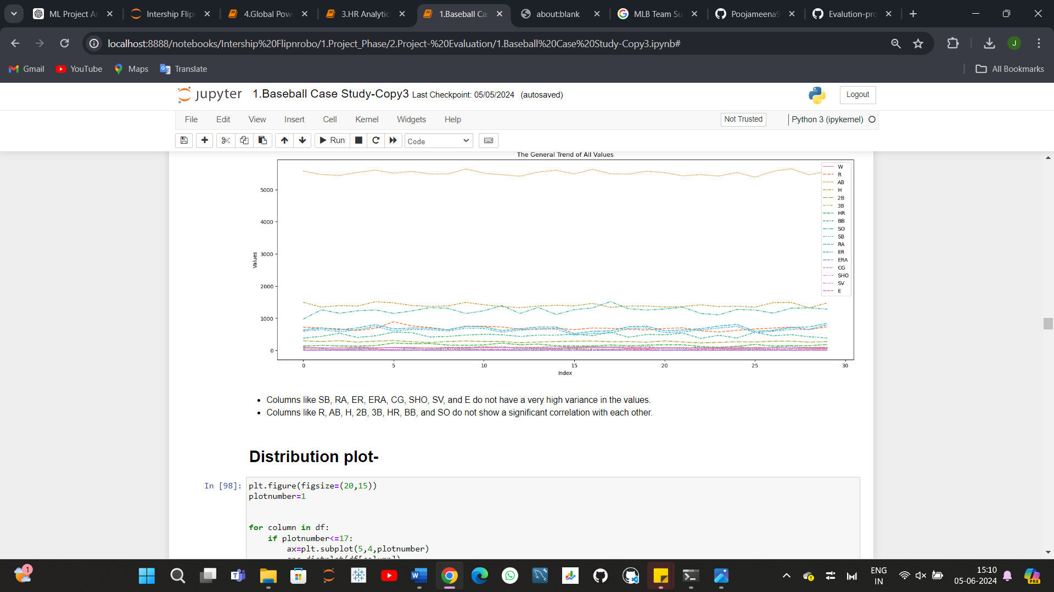

* Columns like SB, RA, ER, ERA, CG, SHO, SV, and E do not have a very high variance in the values.
* Columns like R, AB, H, 2B, 3B, HR, BB, and SO do not show a significant correlation with each other.

Key Insights on Department & Education level of from Pie Plot

**Feature Engineering: Data Pre-processing**

*Feature engineering is the process of transforming raw data into features that better represent the underlying problem to the predictive models, resulting in improved model accuracy on unseen data.*

Feature Engineering is very important step in building Machine Learning model. Some machine learning projects succeed and some fail. What makes the difference? Easily the most important factor is the features used. In Feature engineering can be done for various reason. **Some of them are mention below:**

1. **Feature Importance**: An estimate of the usefulness of a feature
2. **Feature Extraction**: The automatic construction of new features from raw data (Dimensionality reduction Technique like PCA)
3. **Feature Selection**: From many features to a few that are useful
4. **Feature Construction**: The manual construction of new features from raw data (For example, construction of new column for month out date - mm/dd/yy)

There are Varity of techniques use to achieve above mention means as per need of dataset. Some of Techniques important are as below:

* Handling missing values
* Handling imbalanced data using SMOTE
* Outliers’ detection and removal using Z-score, IQR
* Scaling of data using Standard Scalar or Minmax Scalar
* Binning whenever needed
* Encoding categorical data using one hot encoding, label / ordinal encoding
* Skewness correction using Boxcox or yeo-Johnson method
* Handling Multicollinearity among feature using variance inflation factor
* Feature selection Techniques:
* Correlation Matrix with Heatmap
* Univariate Selection – SelectKBest
* ExtraTreesClassifier method

In this case study we will use some of the mention feature engineering Techniques one by one.

1. **Skewness Correction**

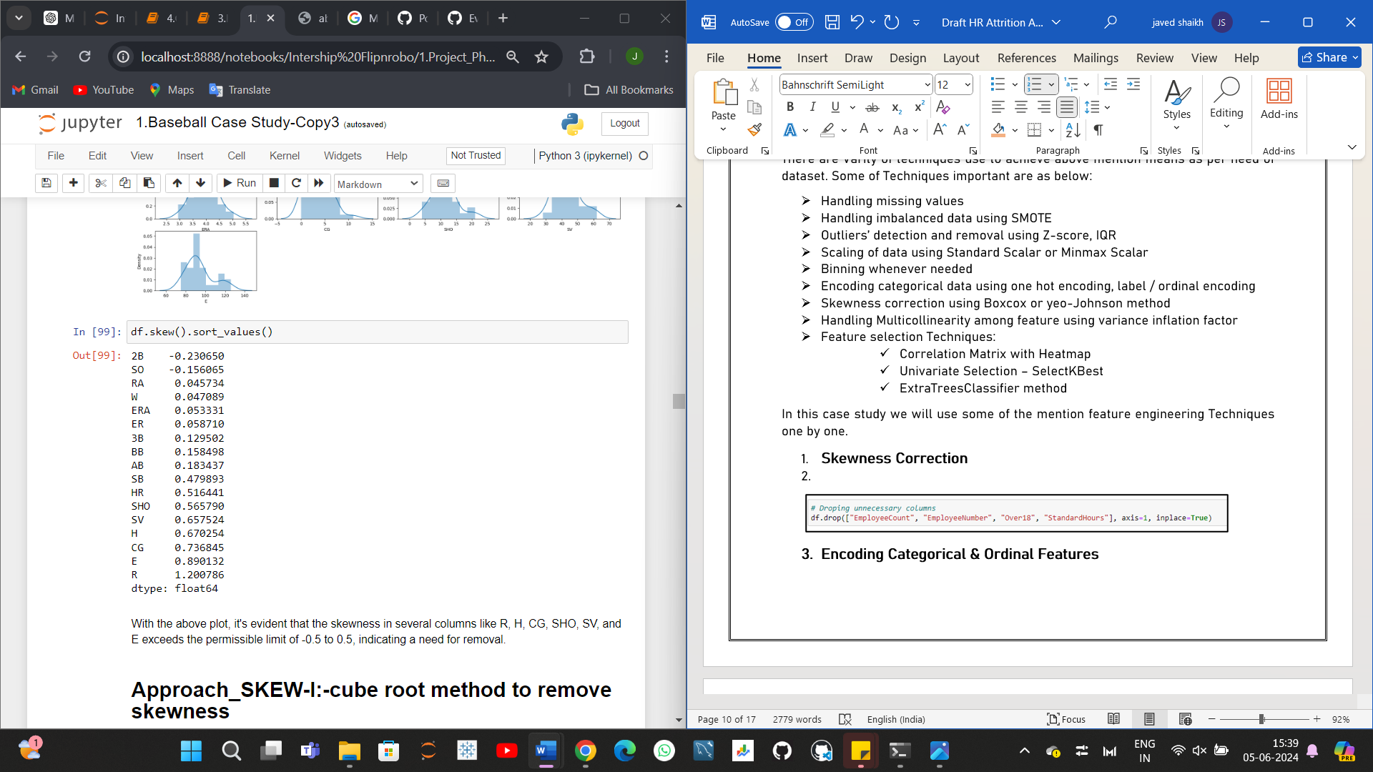

With the above plot, it's evident that the skewness in several columns like R, H, CG, SHO, SV, and E exceeds the permissible limit of -0.5 to 0.5, indicating a need for removal.

**Approach SKEW-I: -cube root method to remove skewness.**

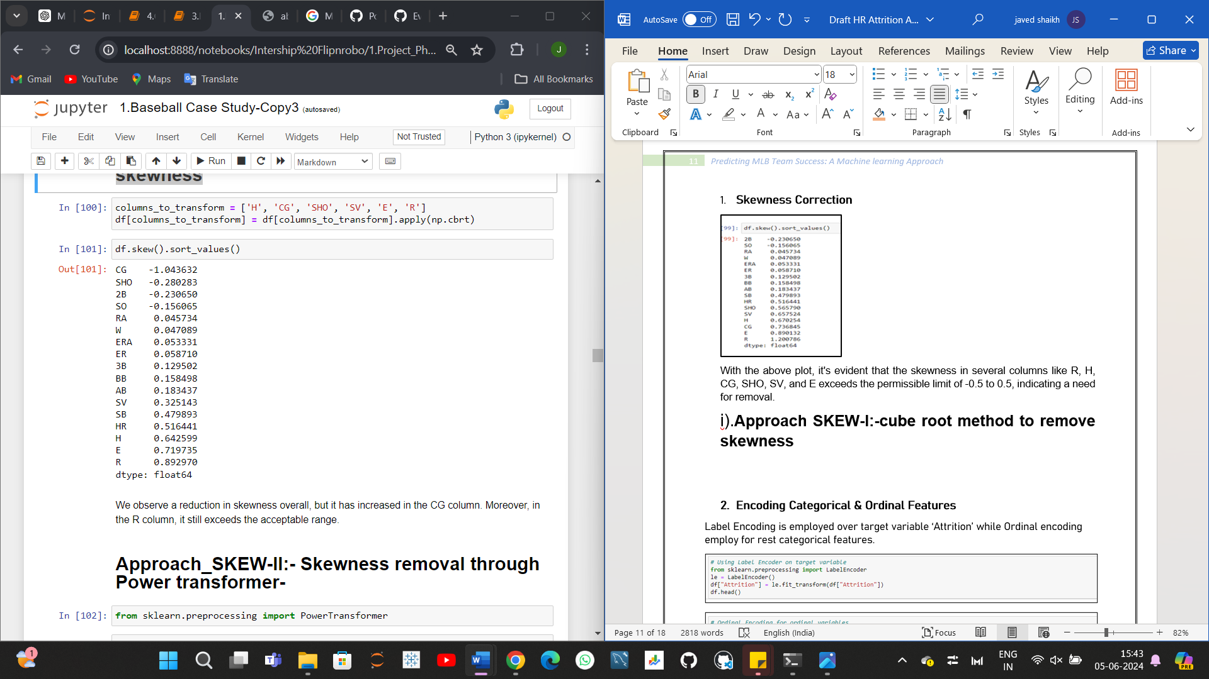

We observe a reduction in skewness overall, but it has increased in the CG column. Moreover, in the R column, it still exceeds the acceptable range.

**Approach_SKEW-II:- Skewness removal through Power transformer-**

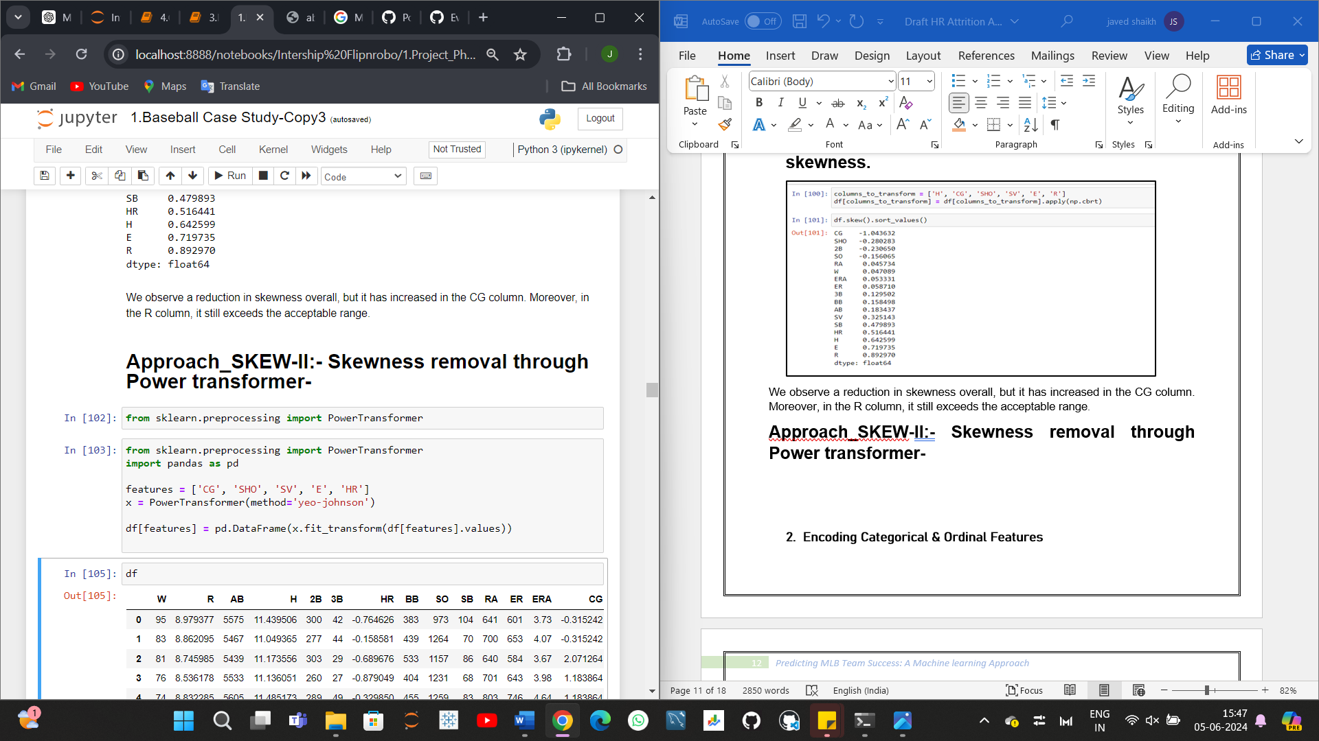

In this case, I refrained from transforming the skewness of R and H because the power transformer resulted in all values becoming 0 in these columns. Consequently, I plan to utilize the log transformation method on the R and H columns to mitigate their skewness.

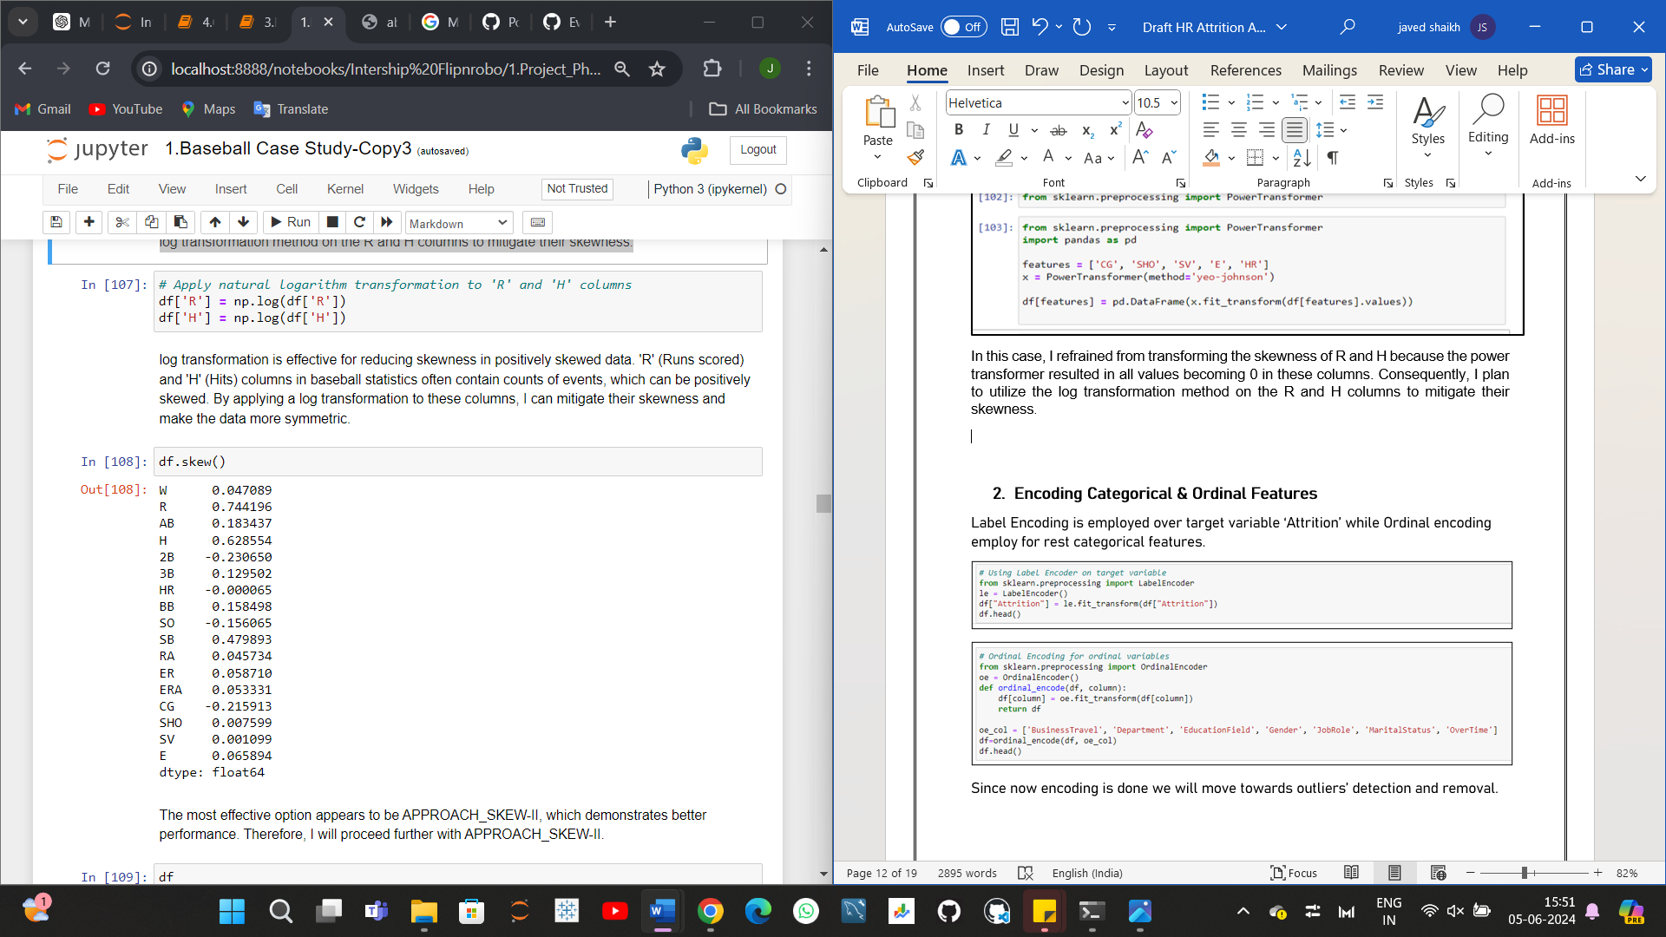

log transformation is effective for reducing skewness in positively skewed data. 'R' (Runs scored) and 'H' (Hits) columns in baseball statistics often contain counts of events, which can be positively skewed. By applying a log transformation to these columns, I can mitigate their skewness and make the data more symmetric.



The most effective option appears to be APPROACH_SKEW-II, which demonstrates better performance. Therefore, I will proceed further with APPROACH_SKEW-II.

1. **Outliers’ detection and removal**

Identifying outliers and bad data in your dataset is one of the most challenging aspects of data cleaning, and it requires careful attention and time to get right. Even with a strong grasp of statistics and the impact of outliers on your data, it's crucial to approach this task cautiously.

Machine learning algorithms are sensitive to the range and distribution of attribute values. Data outliers can spoil and mislead the training process resulting in longer training times, less accurate models and ultimately poorer results. Outliers can be seen in boxplot of numerical feature. We did not added boxplot here as it will make this article length, I left it to reader to further investigate. Now we will use Z-score method for outliers’ detection.

# **Approach_Outlier-I: Removing outliers using the Z-score method.**

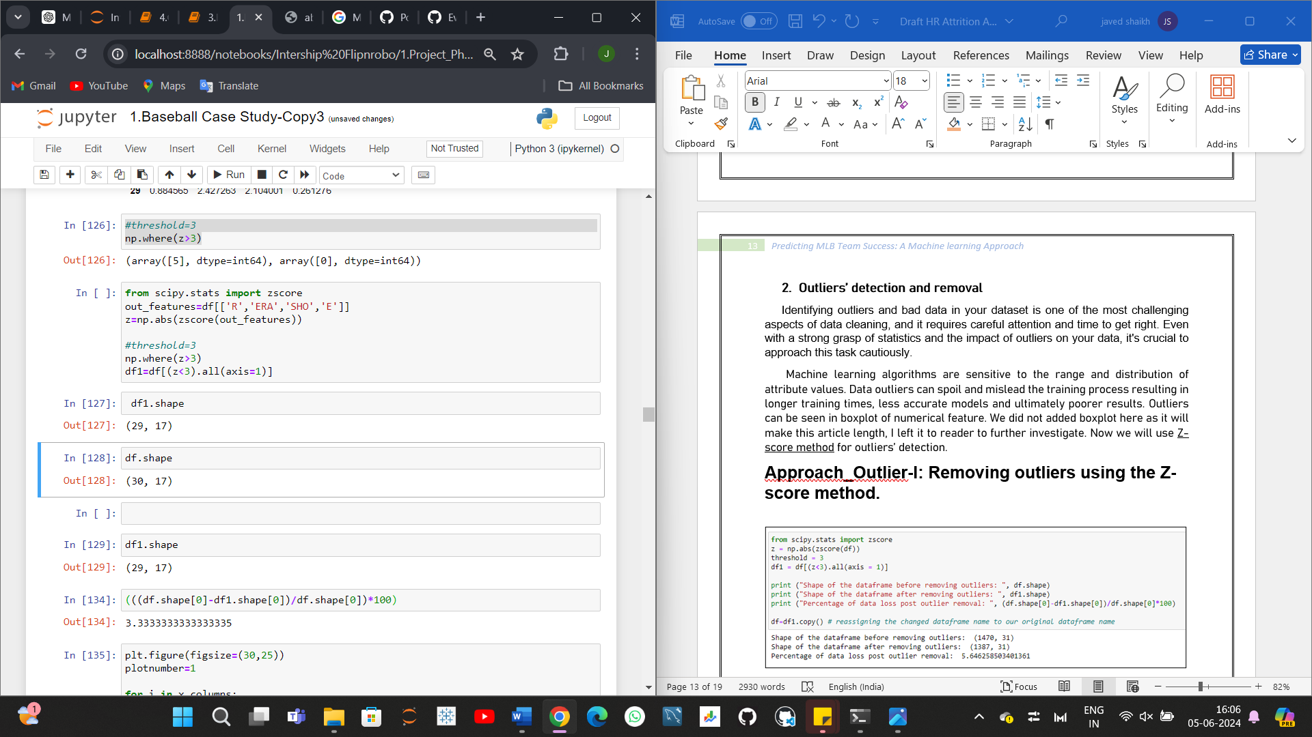

outliers are still present in the SHO and E columns. We will explore alternative methods to remove these outliers.

# **Approach_Outlier-II:-Removing outliers using the IQR method.**

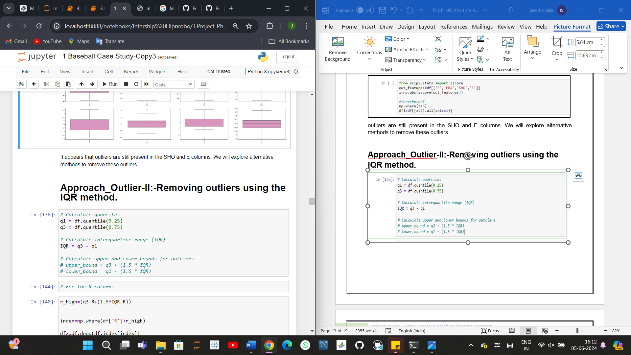

Although the data loss is higher than the acceptable range, standing at 20%, we'll still proceed to build one model using this data.

1. **Correlation Heatmap**

Correlation Heatmap show in a glance which variables are correlated, to what degree, in which direction, and alerts us to potential multicollinearity problems. The bar plot of correlation coefficient of target variable with independent features shown below

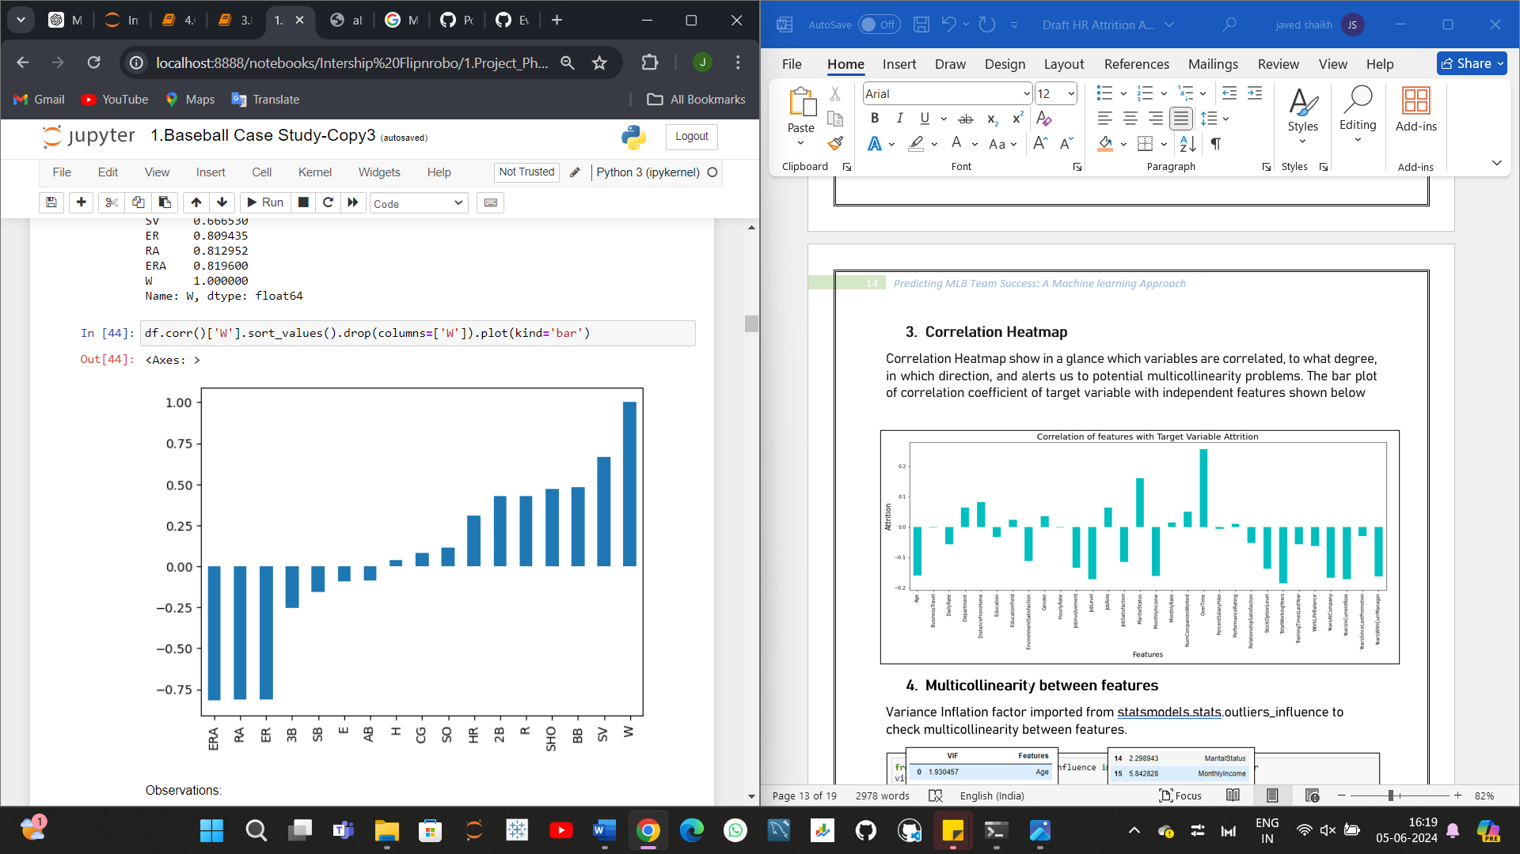

**Observations:**

- RA, ER, ERA, and SV columns have the highest correlation with the target variable.

- RA, ER, and ERA columns exhibit a negative correlation with the target variable.

- H, AB, and E columns have the least correlation with the target variable.

- SHO and BB columns show an average relationship with the target variable.

1. **Scaling of data using Standard Scalar**

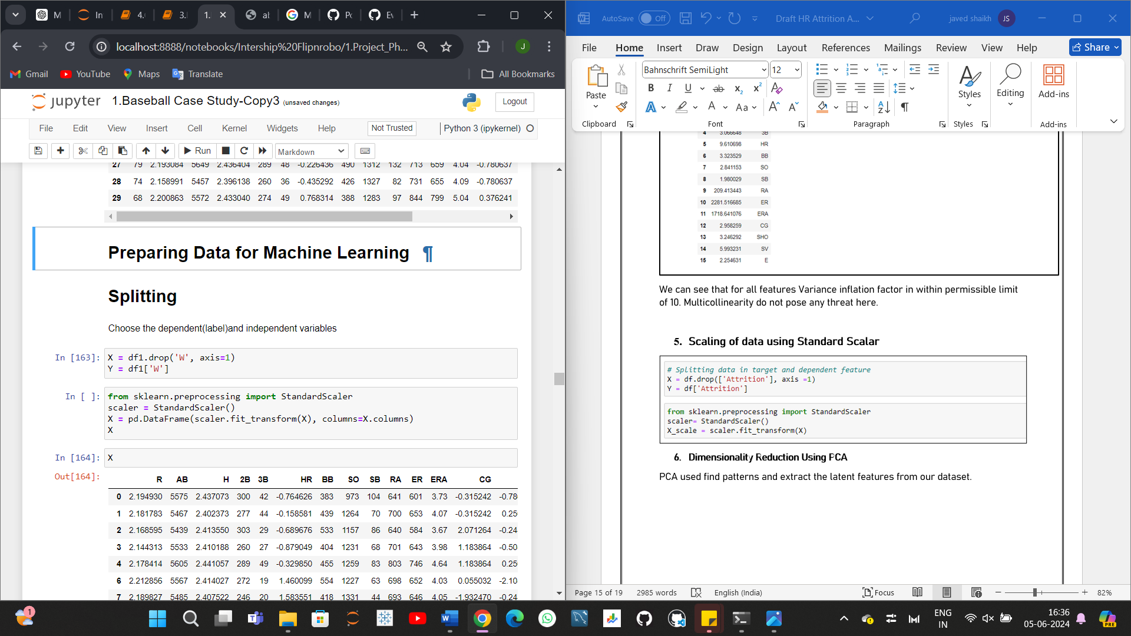

1. **Multicollinearity between features**

Variance Inflation factor imported from statsmodels. stats. outliers influence to check multicollinearity between features.

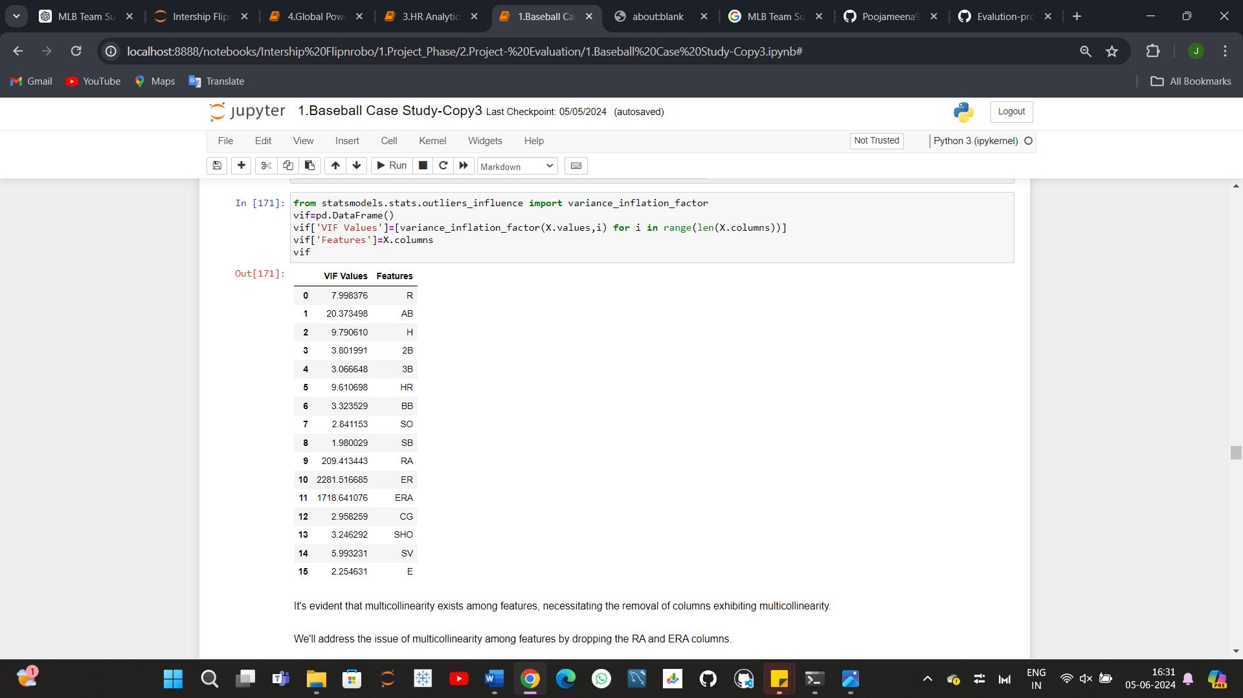

It's evident that multicollinearity exists among features, necessitating the removal of columns exhibiting multicollinearity.

We'll address the issue of multicollinearity among features by dropping the RA and ERA columns.

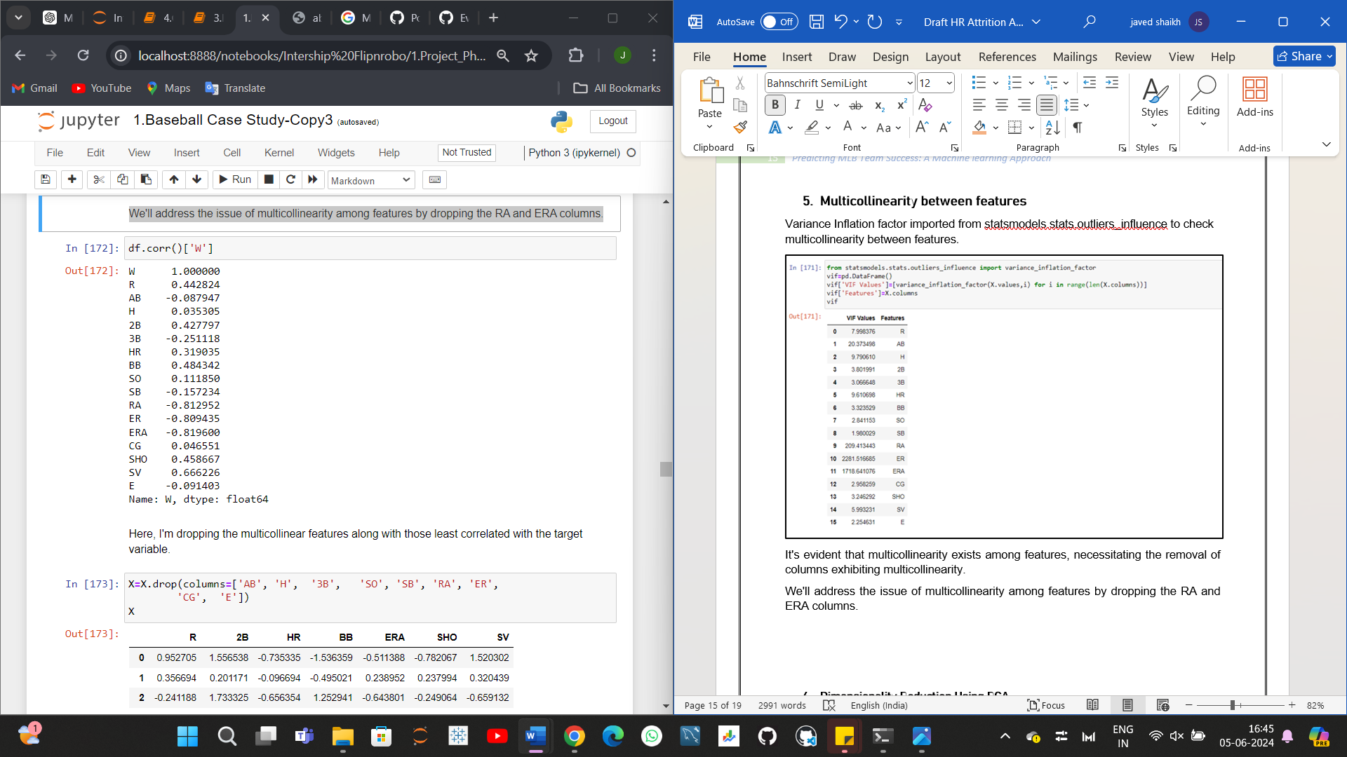

Now that the multicollinearity issue has been addressed and is within an acceptable range, we can proceed with confidence to the next step of model building.

**Machine Learning Model Building:**

First we will build base model using logistic regression algorithim. Best random state is investigated using for loop for random state in range of (0,200).

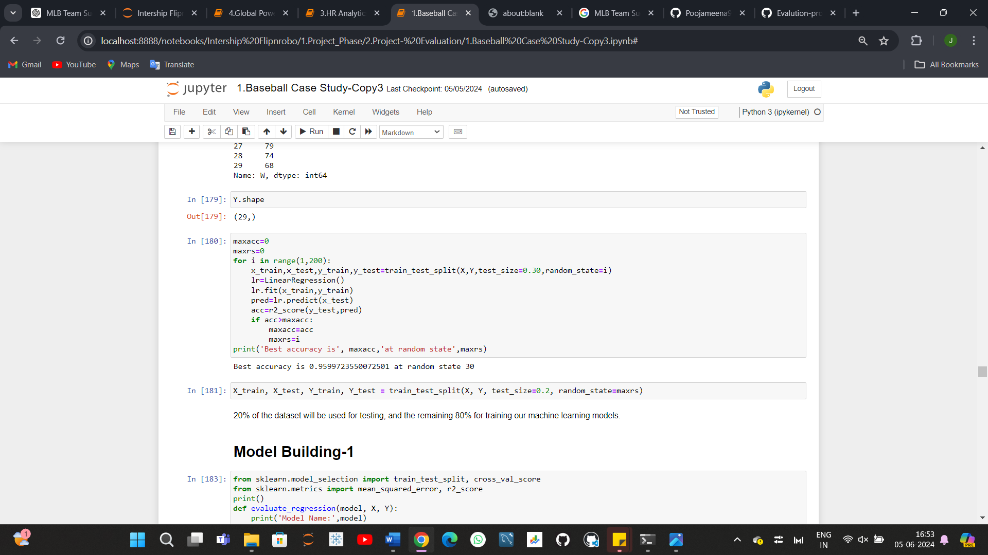

In this section we will build Supervised learning ML model-based regression algorithm. As objective is to predicts the number of wins for Major League Baseball teams in the 2015 season. train_test_split used to split data with size of 0.2.

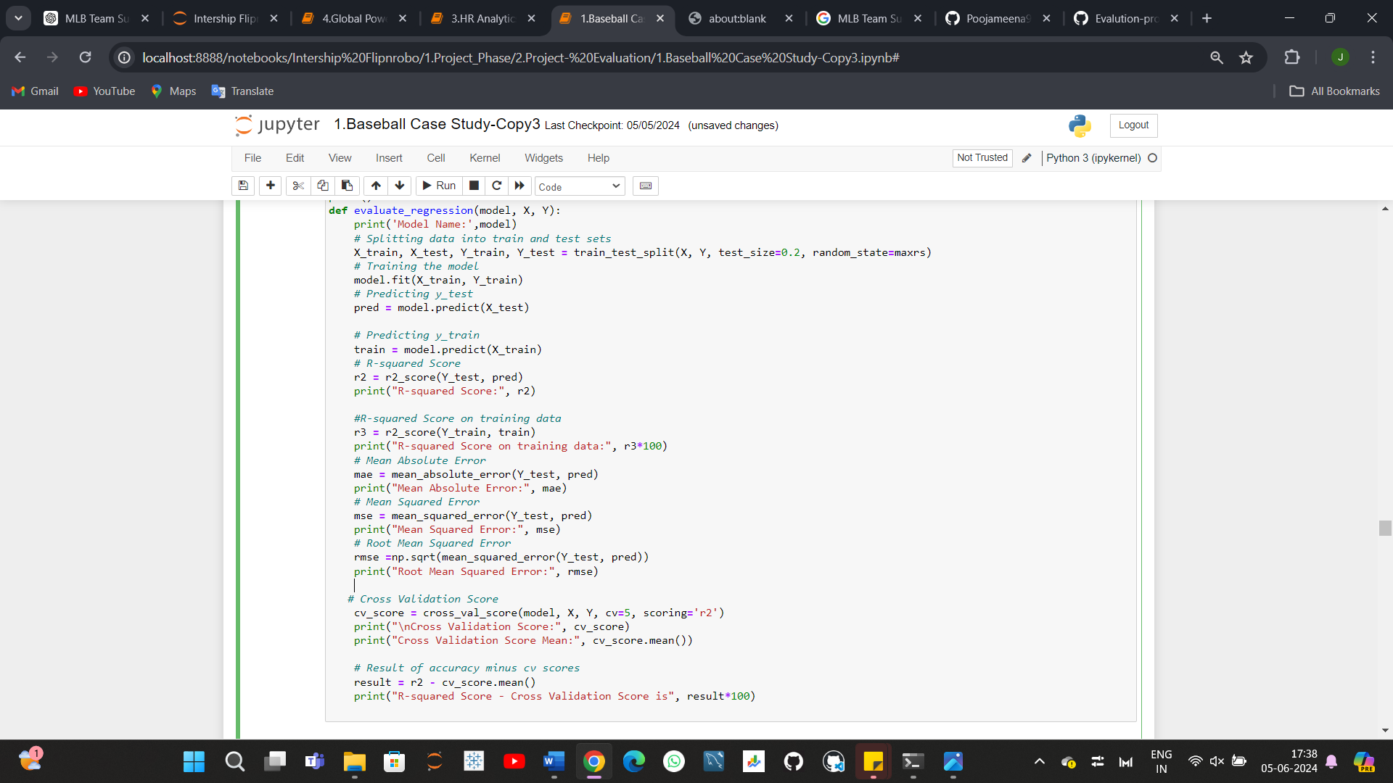

I've created a class to handle train-test splitting, model training, Predicting y_test, Predicting y_train,R-squared Score, R-squared Score on training data,Mean Absolute Error,Mean Squared Error,Root Mean Squared Error, Cross Validation Score,and comparison of accuracy and cross-validation scores for any machine learning model that utilizes this function.

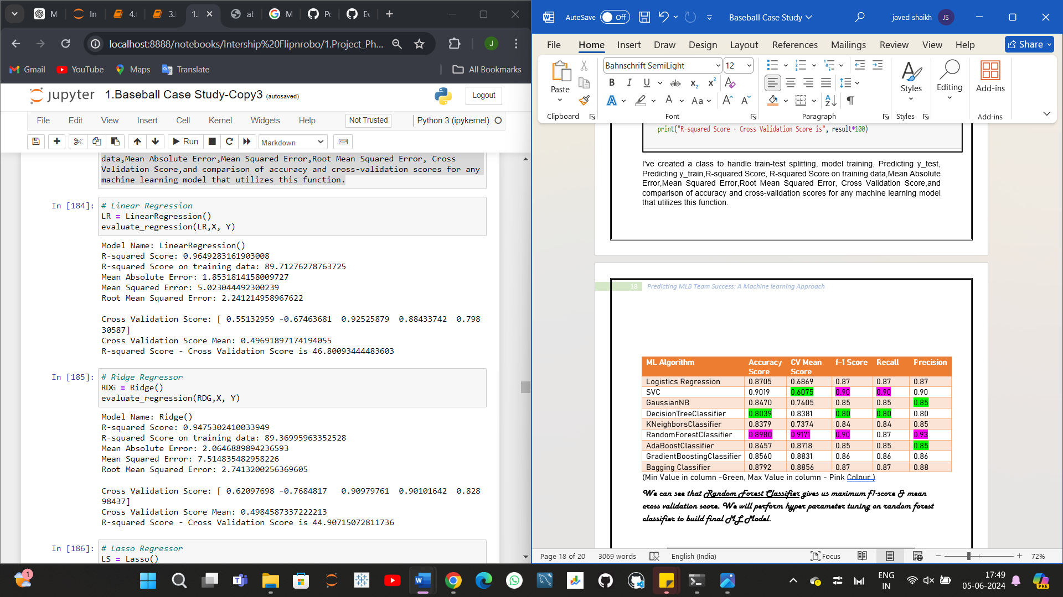

|  |  |  |  |  |  |  |
| --- | --- | --- | --- | --- | --- | --- |
| Model | R-squared Score | Mean Absolute Error | Mean Squared Error | Root Mean Squared Error | Cross Validation Score Mean | Difference bet R-squared Score and CV Score |
| Linear Regression | 0.965 | 1.853 | 5.023 | 2.241 | 0.497 | 46.801 |
| Ridge Regression | 0.948 | 2.065 | 7.515 | 2.741 | 0.498 | 44.907 |
| Lasso Regression | 0.923 | 2.456 | 10.960 | 3.311 | 0.528 | 39.537 |
| Decision Tree Regressor | 0.538 | 6.833 | 66.167 | 8.134 | -1.397 | 193.500 |
| Random Forest Regressor | 0.614 | 6.438 | 55.230 | 7.432 | -0.348 | 96.235 |
| Extra Trees Regressor | 0.676 | 5.240 | 46.403 | 6.812 | -0.141 | 81.706 |
| AdaBoost Regressor | 0.522 | 7.006 | 68.502 | 8.277 | -0.425 | 94.683 |
| Gradient Boosting Regressor | 0.697 | 5.619 | 43.424 | 6.590 | -1.009 | 170.554 |
| XGB Regressor | 0.737 | 5.331 | 37.671 | 6.138 | -1.020 | 175.700 |

While Linear Regression has a higher R-squared score, Lasso Regression shows a smaller difference between the R-squared score and cross-validation score, indicating better generalization capability. Depending on the specific requirements and considerations, either model could be chosen as the preferred option.

We will perform hyper parameter tuning on **Linear Regression** to build final ML Model.

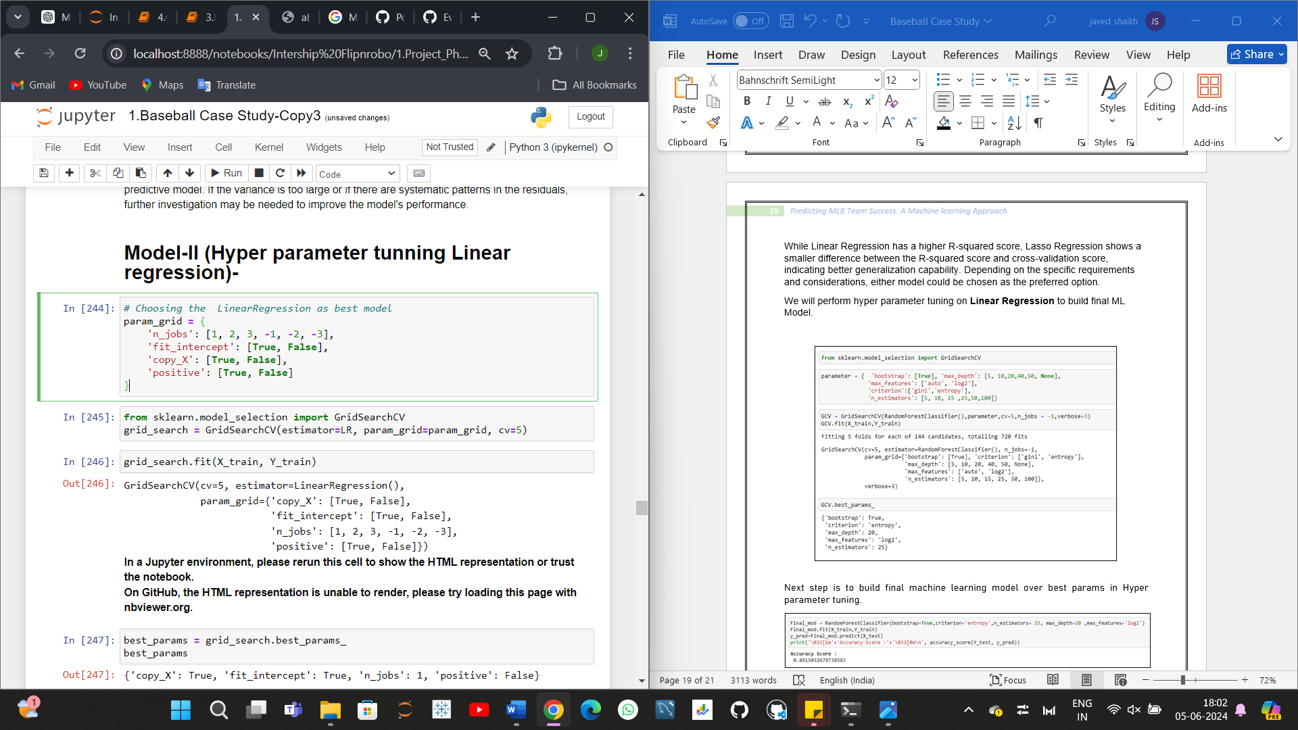

Next step is to build final machine learning model over best params in Hyper parameter tuning.

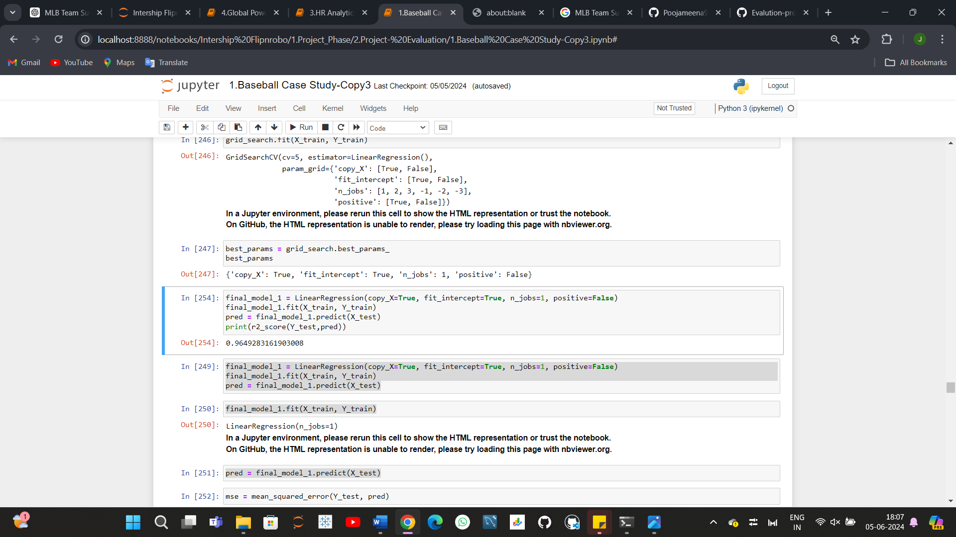

We observe that the final model, after hyperparameter tuning, achieves an R-squared score of 0.96. Given this result, we will use the model with these default values as our final model. Finally, we will save the final model using the Joblib library to facilitate deployment on a cloud platform.

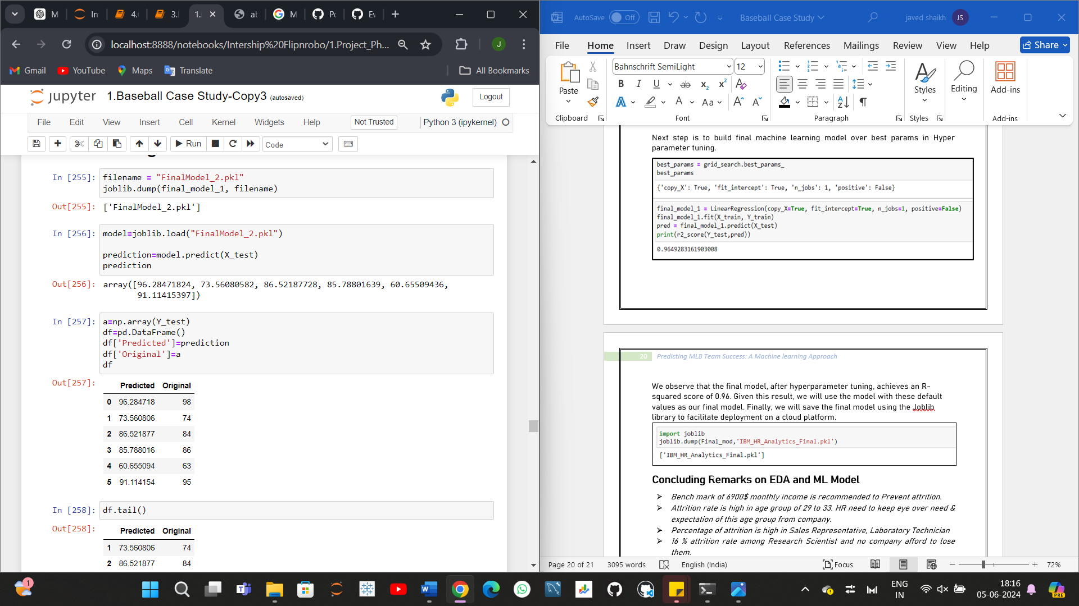

**I have built four models for predicting the number of wins in this dataset:**

**- Model-I:** Achieves an accuracy of 96% with Lasso regularization. Outliers are removed using the Z-score method.

**- Model-II:** Achieves an accuracy of 96% with Linear Regression. Hyperparameter tuning is applied.

**- Model-III:** Achieves an accuracy of 94% with Lasso regularization. Outliers are removed through the IQR method and Select K-Best feature selection is applied.

**- Model-IV:** Achieves an accuracy of 94% with Ridge regularization. Feature selection is performed using Principal Component Analysis (PCA).

You can find this in my [GitHub Profile](https://github.com/javedns07/Project-Evaluation/blob/main/1.Baseball%20Case%20Study.ipynb).

**Concluding Remarks on EDA and ML Model: -**

**Successful Model Development**: Our project successfully developed a machine learning model to predict the number of wins for MLB teams based on historical performance metrics.

**Key Predictive Features Identified:** Through exploratory data analysis and statistical testing, we identified crucial features such as runs, hits, home runs, and errors that significantly influence a team's success.

**Best Performing Model:** The Linear Regression emerged as the best performing model, demonstrating high accuracy and robustness with the lowest Mean Squared Error (MSE) and Mean Absolute Error (MAE), and the highest R-squared (R²) value.

**Insightful Findings:** The analysis provided valuable insights into the factors that drive team success, offering a data-driven basis for strategic decision-making in team management.

**Practical Applications:** The predictive model and identified key factors can help team managers and analysts in making informed decisions regarding player acquisitions, game strategies, and other operational aspects.

**Future Enhancements:** Future work could involve incorporating additional features, exploring more advanced machine learning techniques, and testing the model's applicability across different seasons and leagues.

**Broader Implications:** This project underscores the potential of data science and machine learning in sports analytics, paving the way for more sophisticated and impactful applications in the field of sports management.

You can get code of this case study from my [GitHub Profile](https://github.com/javedns07/Project-Evaluation/blob/main/1.Baseball%20Case%20Study.ipynb) .